**Auctions** Ending soon Recently listed No reserve

Auctions About Car Bids Sell my car

Home Page

Sign in

Search for cars

Car Bids

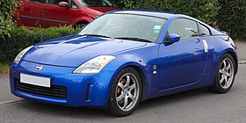

**2005 Nissan 350z**

Ending in 2 days

Very clean 350z with 120,000kms

**2005 Nissan 350z**

Ending in 2 days

Very clean 350z with 120,000kms

**2005 Nissan 350z**

Ending in 2 days

Very clean 350z with 120,000kms

Selecting a car

Car Bids

**2005 Nissan 350z**

Very clean 350z with 120,000km

Auctions About Car Bids Sell my car

Search for cars

Sign in



View more



Overview

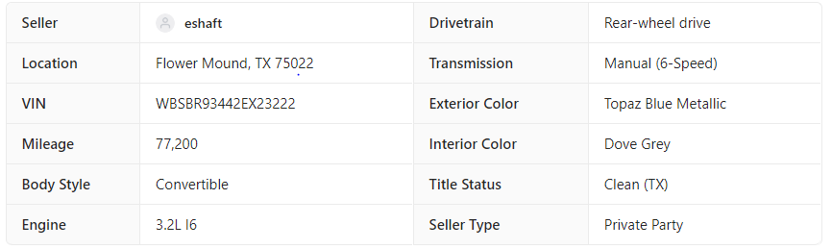

Ending on 12/08/2020 6:00 aest

Highest bid: 12,000

Number of bids: 4

Bid now